Run the project and execute below URL

<http://localhost:28470/editor.aspx?cmNumber=1234-123456>

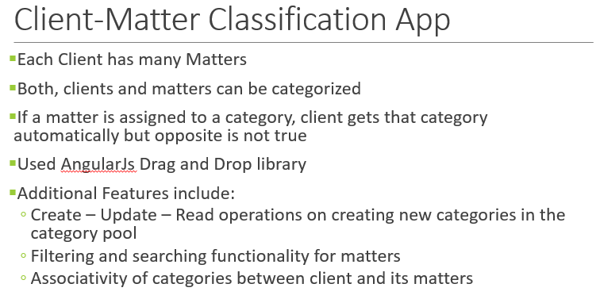

You can drag categories from right panel into Client/Matter category sections.

